**Experiment No:03**

**Aim:** To include icons, images, fonts in Flutter app

**Theory:**

**Enhancing Visual Appeal and Functionality in Flutter Apps with Icons, Images, and Fonts**

Incorporating icons, images, and custom fonts in a Flutter app is pivotal for elevating both its visual appeal and functionality. Below, we provide a comprehensive overview of how developers can seamlessly integrate these assets into their applications:

1. **Icons:**

* **Built-in Support:** Flutter offers extensive support for icons through the Icons class, housing a vast collection of Material Design icons.
* **Displaying Icons:** Developers can utilize the Icon widget to showcase icons within their apps effortlessly. Simply specify the desired icon using properties such as Icons.<icon_name>, along with options for size and color customization.

1. **Images:**

* **Asset Management:** To include images in a Flutter app, developers can organize image files within the assets directory of their projects.
* **Displaying Images:** Utilize the Image widget to render images. Employ the Image.asset() constructor to load images from the asset bundle, specifying the image asset path as a parameter. This allows for seamless integration and display of images within the app's UI.

1. **Fonts:**

* **Custom Font Integration:** Developers can seamlessly integrate custom fonts into their Flutter apps by including font files (e.g., .ttf or .otf) within the project's fonts directory.
* **Declaration in pubspec.yaml:** Declare the custom fonts in the pubspec.yaml file under the flutter section using the fonts property. This step ensures that Flutter recognizes and includes the custom fonts in the app bundle.
* **Applying Custom Fonts:** Once declared, developers can apply the custom font to text elements within their app's UI using the fontFamily property in the TextStyle widget. This grants developers flexibility in achieving a unique and cohesive typographic style throughout the application.

**Step-by-Step Guide:**

1. **Adding Icons:**

* Utilize the Icon widget with the desired icon from the Icons class.
* Customize the icon size, color, and other properties as per the app's requirements.

1. **Incorporating Images:**

* Organize image files within the assets directory.
* Employ the Image.asset() widget to load images from the asset bundle, specifying the image asset path.

1. **Integrating Custom Fonts:**

* Place custom font files within the fonts directory of the Flutter project.
* Declare custom fonts in the pubspec.yaml file under the flutter section using the fonts property.
* Apply the custom font to text elements by specifying the fontFamily property in the TextStyle widget.

**Code:**

import 'package:flutter/material.dart';

void main() {

runApp(MyApp());

}

class MyApp extends StatelessWidget {

@override

Widget build(BuildContext context) {

return MaterialApp(

title: 'Flutter Icons, Images, and Fonts Example',

theme: ThemeData(

primarySwatch: Colors.blue,

),

home: MyHomePage(),

);

}

}

class MyHomePage extends StatelessWidget {

@override

Widget build(BuildContext context) {

return Scaffold(

appBar: AppBar(

title: Text('Expt-3'),

),

body: Center(

child: Column(

mainAxisAlignment: MainAxisAlignment.center,

children: <Widget>[

Text(

'Flutter-Expt:3 Amit Nayak',

style: TextStyle(

fontSize: 40,

color: Colors.red,

),

),

Icon(

Icons.favorite,

size: 50,

color: Colors.red,

),

SizedBox(height: 20),

Image.asset(

'assets/comp.png',

width: 100,

height: 100,

),

SizedBox(height: 20),

Text(

'Custom Font Example',

style: TextStyle(

fontFamily: 'Roboto', // Custom font family

fontSize: 24,

fontWeight: FontWeight.bold,

),

),

],

),

),

);

}

}

**Folder Structure and pubspec.yaml :**

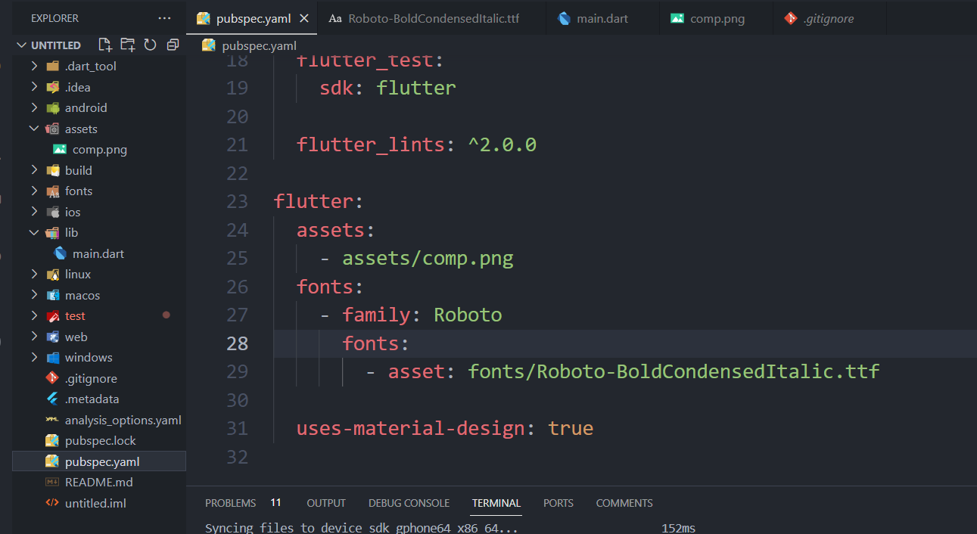

**Output:**

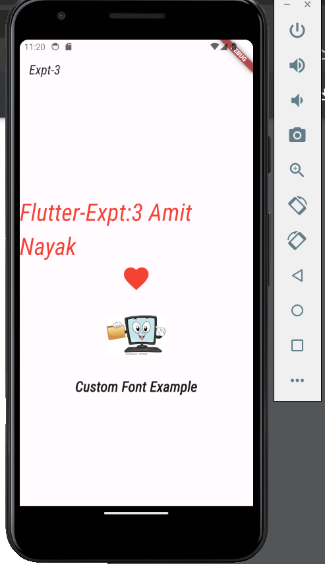

**Conclusion:** We have successfully understood and implemented the images , fonts and Icons in a Flutter Application.